ONE PAGE BIODATA
Name of Teaching Staff | Gavade Jay Prakash |  |  | 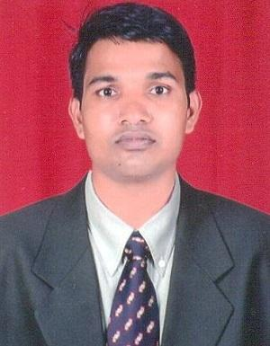
Date of Birth | 05/10/1977
Designation | Assistant Professor
Department | Mechanical Engineering
Date of Joining the Institution | 02/07/2012
Caste | Maratha
Qualification With  Class / Grade | UG | PG |  | Ph.D.
 | BE (Production)  First Class with Distinction | ME (Production)  First Class |  | P.h.D Persuing
Total Experience in Years | Teaching | Industry |  | Research
 | 12 Yrs. | 6 Yrs. |  | -------
Paper Published | National | ___ | International |  | 04
Paper Presented in Conferences | National | 02 | International |  | ______
Ph.D. Guide? Give Field & University | Field | _____ | University |  | ______
Ph.Ds. / Projects Guided | Ph.D. | _____ | Projects at Masters Level |  | ______
Books Published /  IPRs / Patents | ____
Professional membership | ISTE
Consultancy Activities | ____
Awards | ____
Grants Fetched | ____
Interaction with Professional Institutions | ____

