ONE PAGE BIODATA
Name of Teaching Staff | Mr. Rahul AshokPatil |  |  | 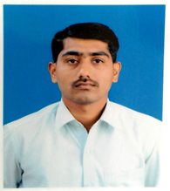
Date of Birth | 04/04/1989
Designation | Assistant Professor
Department | Mechanical Engineering
Date of Joining the Institution | 02/07/2012
Caste | Open
Qualification With  Class / Grade | UG | PG |  | Ph.D.
 | Mechanical Engg.  First class with Distinction | M.E Design  First class with Distinction
Total Experience in Years | Teaching | Industry |  | Research
 | 13 Years
Paper Published | National | 3 | International |  | 1
Paper Presented in Conferences | National | - | International |  | -
Ph.D. Guide? Give Field & University | Field | - | University |  | -
Ph.Ds. / Projects Guided | Ph.D. | - | Projects at Masters Level
Books Published /  IPRs / Patents | -
Professional membership | ISTE
Consultancy Activities | -
Awards | 1
Grants Fetched | -
Interaction with Professional Institutions | -

