ONE PAGE BIODATA
Name of Teaching Staff | Prof.Mane Shashikant Ganpat |  |  | 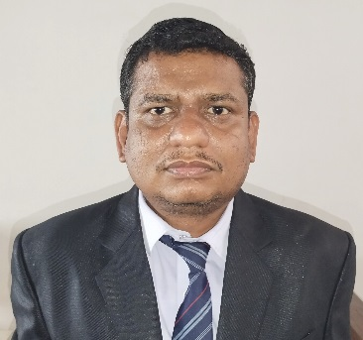
Date of Birth | 19/11/1983
Designation | Assistance Professor
Department | Mechanical
Date of Joining the Institution | 10/10/2016
Caste | NT-2
Qualification With  Class / Grade | UG | PG |  | Ph.D.
 | B.E.  First Class | M.tech  Second Class
Total Experience in Years | Teaching | Industry |  | Research
 | 14 year 4months
Paper Published | National |  | International |  | 3
Paper Presented in Conferences | National | 3 | International |  | 1
Ph.D. Guide? Give Field & University | Field | Nil | University |  | Nil
Ph.Ds. / Projects Guided | Ph.D. | Nil | Projects at Masters Level |  | Nil
Books Published /  IPRs / Patents | Nil
Professional membership | ISTE Member
Consultancy Activities | Nil
Awards | Nil
Grants Fetched | Nil
Interaction with Professional Institutions | Nil

