ONE PAGE BIODATA
Name of Teaching Staff | Mr. Sanjay Dhondiba Kulal |  |  | 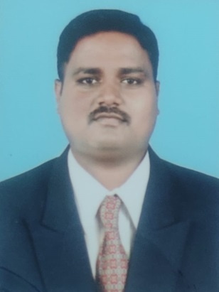
Date of Birth | 06 August 1991
Designation | Assistant Professor
Department | Mechanical Engineering
Date of Joining the Institution | 27/06/2016
Caste | Hindu-Dhangar
Qualification With  Class / Grade | UG | PG |  | Ph.D
 | 1St Class with Distinction | First Class |  | Pursuing
Total Experience in Years | Teaching | Industry |  | Research
 | 10.6 | - |  | -
Paper Published | National | 05 | International |  | -
Paper Presented in Conferences | National | - | International |  | -
Ph.D. Guide? Give Field & University | Field | - | University |  | -
Ph.Ds. / Projects Guided | Ph.D. | - | Projects at Masters Level |  | -
Books Published /  IPRs / Patents | -
Professional membership | ISTE
Consultancy Activities | -
Awards | -
Grants Fetched | -
Interaction with Professional Institutions | -

