ONE PAGE BIODATA
Name of Teaching Staff | Mr. Sunilkumar Machhindra Bandgar |  |  | 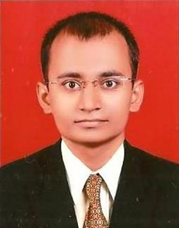
Date of Birth | 07 April 1988
Designation | Assistant Professor
Department | Mechanical Engineering
Date of Joining the Institution | 29/02/2020
Caste | Hindu-Dhangar
Qualification With  Class / Grade | UG | PG |  | Ph.D.
 | First Class | 1st Class With Distinction |  | -
Total Experience in Years | Teaching | Industry |  | Research
 | 07 | - |  | -
Paper Published | National | 02 | International |  | -
Paper Presented in Conferences | National | 01 | International |  | -
Ph.D. Guide? Give Field & University | Field | - | University |  | -
Ph.Ds. / Projects Guided | Ph.D. | - | Projects at Masters Level |  | -
Books Published /  IPRs / Patents | -
Professional membership | ISTE
Consultancy Activities | -
Awards | -
Grants Fetched | -
Interaction with Professional Institutions | -

