Fabtech Technical Campus, College of Engineering & Research, Sangola
DepartmentofMechanical Engineering
FACULTYPROFILE
NameofTeachingStaff | Prof. Priyanka P. Pawaskar |  |  |  |  |  | 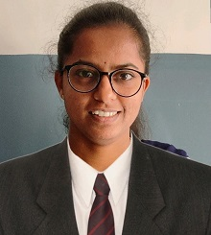
Designation | AssistantProfessor
Department | Mechanical Engineering
Date of Joining the  Institution | 01/04/2021
QualificationWithClass/Grade | UG |  | PG |  | Ph.D.
 | B.E.with First Class |  | M.E.with First Class |  | Pursuing
TotalExperience inYears | Teaching | Approval Experience | Industry |  | Research
 | 11 | - | - |  | -
PapersPublishedin  Journals | National |  | 01 | International |  |  | 5
PapersPresentedin  Conferences | National |  | 01 | International |  |  | 1
STTP/Seminars/FDPs/ConferencesAttended | STTP-FDP- |  | 15 | Workshops&Seminars | 06 | Conference | 02
PhD Guide? Give Field & University | Field |  | - | University |  |  | -
PhDs/M E Projects  Guided | PhD |  | - | ProjectsatMasterslevel |  |  | 02
ProfessionalMembership | ISTE
Subject current semester | Theory of Machines I, Theory of Machines II, EEE

